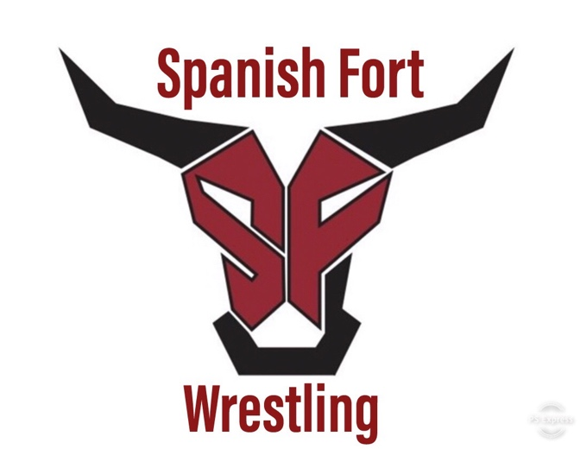

Information

Practice start date for middle school and 9th graders October 19th
Everyone else next Monday the 26th.

Times- After school until 5:30 every weekday until events start.

Transportation- ride the school bus to the high school from the middle school.

What is needed to practice.

A current physical and other paperwork from dragonflymax.com. A link is found in under Files/Paperwork at https://www.bcbe.org/sfhs.

You will also find other important information on our website such as wrestling shoes and calendar and a sign up for parents.

Shorts, T Shirt and tennis shoes- eventually wrestling shoes (can be found online for best prices. Good brands are Asics and adidas)

We will have a parent meeting after the first week of practice probably on October 30th at 5:30PM

